# COVID-19 Admission of patients with suspected or confirmed disease

## *Executive summary*

## Introduction

This guideline is intended to guide doctors and nurses through the processes associated with the admission of a suspected or confirmed COVID-19 patient. It should be followed alongside other guidelines on how to manage patients and SOPs on PPE usage and investigations.

The guideline has been written in recognition that staff are under extra pressure as they care for these patients, whilst ensuring they do not put themselves at risk, meaning that they need to plan carefully each contact with the patients. The importance of deliberate planned communication with patients and relatives is also recognised in a context where escorts cannot accompany patients during their admission.

## Target users

* Doctors
* Nurses

## Target area of use

* Ward

## Key areas of focus / New additions / Changes

The guideline describes the preparation required before admission and the important extra steps required during the admission process of these patients.

## Limitations

None

## Decision about where to admit patients

Patients with confirmed or suspected COVID-19 may be referred from a number of different settings including some that are non-standard to usual CSD procedures.

For each admission, the risk of transmitting the illness from the patient to other patients and staff and the risk of transmitting it to the patient must be considered. This decision must be discussed with a consultant before the patient leaves the OPD or reaches the ward. The flow chart below addresses most of the common situations that arise. Paitents who are though to fall into the “unlikely COVID” group can be discussed with the one of the non-COVID consultants. All other patients could be discussed with the COVID consultant on-call (7111440).

Where there is doubt the patient should be held in an isolation area (such as the OPD room in the hot zone), whilst all the issues are discussed with the COVID consultant on-call.

If a patient is unlikely to have COVID-19 and has another condition that might put them at risk of complications if they get the illness, then it may be best to admit them to a side room to protect them from infection.

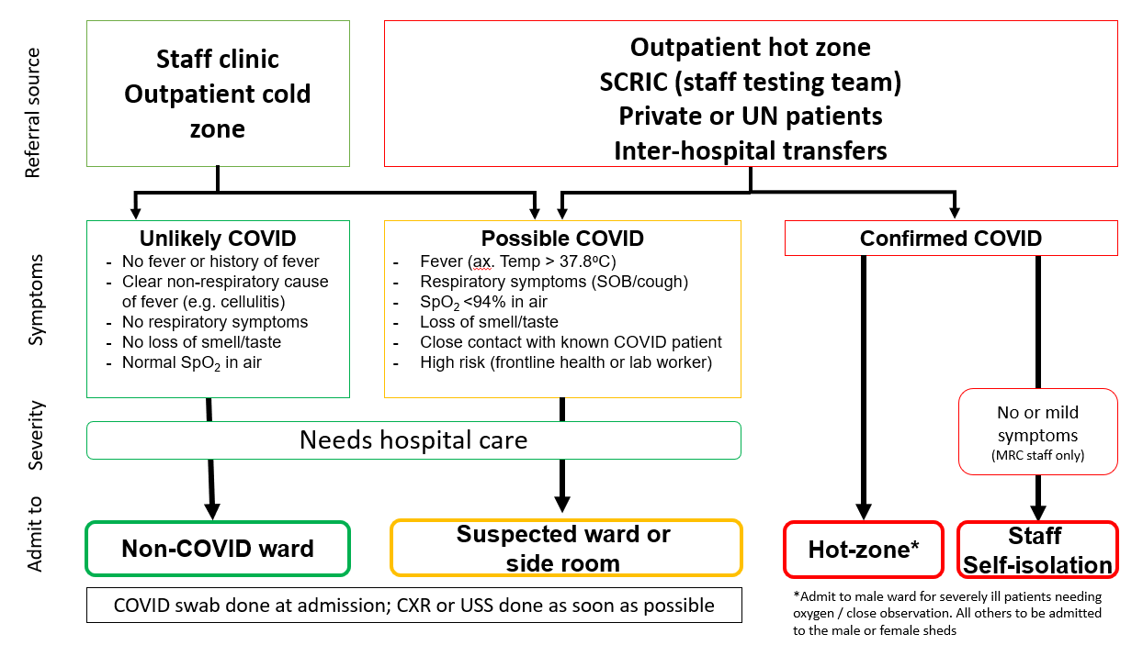

## Transfer to the ward

Once a decision has been made about where a patient should be admitted, the responsible doctor must check there is a suitable bed space available (by calling the bed manager on 2255585). If the patient will need urgent medical care, the doctors on the ward should be alerted by telephoning them. Otherwise, the doctors on the ward should be alerted by reporting the admission on the Whatsapp group, which can include any specific instructions for the management of the patient, (this is usually done by the admitting doctor in OPD) and by the bed manager speaking to doctors on the ward.

Prior to the transfer of any patient being admitted to a side room, the suspected ward or the confirmed ward, the bed space or room should be prepared by the nursing staff. This is best done just after a vacated room or bed has been cleaned by the ward attendants. A checklist is provided (Appendix 1) outlining equipment that should be present in the isolation rooms and in the hot zone ward spaces before patients are admitted there.

Once the space is prepared, the auxiliary nurse working in the OPD should escort the patient to the ward. The nurse will need clear instructions about where the patient is to be admitted. Patients who are suspected to have COVID-19 should NOT stop at the reception desk for their observations to be checked, but should proceed straight into their isolation area and be assessed there. Patients with confirmed COVID should not enter CSD but go straight to the in-patient hot-zone.

## Patient management

It may be appropriate to take a history by phone or using the intercom in order to reduce time spent in the hot zone and wearing PPE. If a patient is requiring oxygen or is unwell, assess the patient at the bedside. It is very important that patients are given a good opportunity to be properly assessed and to ask questions. It may also be necessary for doctors to take on roles that are usually carried out by nurses – for instance, giving urgent iv drugs or taking observations, if they are needed at a time when the doctor has another reason to enter the room.

Ensure that all new admissions have a medication chart completed (even if not on any medications) and that it is placed on a clipboard next to the patient’s bedside.

### Escorts

The default position is that children must have an escort with them and adults should not have an escort with them. However, if there is a specific reason why an escort is required, this should be discussed with the COVID consultant on-call. The escort should be swabbed at the time the decision is made to allow them to join their patient (either in OPD or when they arrive on the ward if they are brought in at a later point in the admission).

### Investigations

Investigations must be carefully planned. A checklist of recommended investigations is provided in Appendix 2 – a version of this that can be copied into EMRS is available on sharepoint. These do not necessarily need to be taken at the time of admission, but, where clinically appropriate, may be deferred until the next working day.

COVID-19 nasopharyngeal and oropharyngeal swabs can be taken at any time of the day. It is best if they are done as soon as possible after the decision to admit them is made – ideally within the OPD hot zone. The clinical laboratory staff should be informed when they are ready and the samples delivered to the laboratory at an agreed time.

Other laboratory samples should be taken when necessary, again in discussion with the clinical laboratory staff. They need to be warned at least 30 minutes prior to delivery of samples.

Lung POCUS and ECHOcardiography can be done in discussion with the trained doctors. CXR can be done when the patient is in the hot zone during working hours and should be performed in all suspected COVID cases. This should be discussed with the X-ray staff.

## Treatment escalation plan

A treatment escalation plan must be completed as part of the admission process (Appendix 3 and inside EMRS). This should be reviewed by a consultant within 48 hours and then on a weekly basis.

## Communication

Communication is very important and is addressed fully in a specific guideline. It is particularly important that the name and phone number of a relative is recorded in the notes. Here we outline important information that should be provided on admission to patients (Appendix 4), to relatives (Appendix 5) and the answers to Frequently Asked Questions (Appendix 6).

## Important people to alert

There are special arrangements for certain groups of staff requiring other people to alert to their admission.

* Staff admissions with suspected or confirmed COVID-19 (or their immediate family members) – alert the SCRIC team
* UN admissions – alert Fatoumatta Sumareh on 1903.

## Reference

<https://www.who.int/emergencies/diseases/novel-coronavirus-2019/question-and-answers-hub> accessed 6/08/2020

|  |  |  |
| --- | --- | --- |
| **Written by:** | Name: Karen Forrest | Date: 18 August 2020 |
| **Reviewed by:** | Name: Helen Brotherton | Date: 26 August 2020 |
| **Version:** | **Change history:** | **Review due date:** |
| 1.0 | New document | 26 August 2022 |
| Review Comments (*if applicable)* |  |  |

## Appendix 1: Checklist for isolation rooms and hot zones wards

### Each bed space:

Bed cleaned and made

Chair

Locker

### Each ward space:

Observation monitor

Stethoscope

Prayer mat

Drinking water

### For the isolation rooms

All of the above, plus:

Intercom is working

Negative pressure system turned on and working

## Appendix 2: Recommended investigations

|  |  |  |  |
| --- | --- | --- | --- |
| **Laboratory tests** | | | |
| COVID-19 swabs | Done Not done | Blood sugar | Done Not done |
| FBC | Done Not done | ALT | Done Not done |
| Sodium | Done Not done | AST | Done Not done |
| Potassium | Done Not done | Bilirubin | Done Not done |
| Urea | Done Not done | LDH | Done Not done |
| Creatinine | Done Not done |  |  |
| **Imaging** |  |  |  |
| Chest X-ray | Done Not done | Lung POCUS | Done Not done |
| ECHO (if signs of cardiac disease) | | Done Not done | |

## Appendix 3: Treatment escalation plan

|  |  |  |  |  |  |  |  |  |
| --- | --- | --- | --- | --- | --- | --- | --- | --- |
| **Person completing form** | | |  | | | Designation | |  |
| Diagnoses |  | | | | | | | |
| Current problem list |  | | | | | | | |
| Admissions in last 1 year? | | |  | | | If yes, number | |  |
| If yes, treatments given and response |  | | | | | | | |
| **Overall rationale for current treatment decisions** | | | | | | | | |
|  | | | | | | | | |
| **If the patient deteriorates:** | | | | | Comments | | | |
| They are for routine observations | | | Y N Unk | |  | | | |
| An NG tube should be placed | | | Y N Unk | |  | | | |
| iv fluids are appropriate | | | Y N Unk | |  | | | |
| iv antibiotics are appropriate | | | Y N Unk | |  | | | |
| CPAP is appropriate | | | Y N Unk | |  | | | |
| Referral for critical care or dialysis is appropriate | | | Y N Unk | |  | | | |
| CPR is appropriate | | | Y N Unk | |  | | | |
| **Broad treatment categories** (circle appropriate category) | | | | | | | | |
| Palliative care | | Acute medical response if deteriorates | | | | | Full treatment | |
| (observations may be appropriate, but no need to respond acutely if deteriorates) | | (respond to abnormal observations, do not attempt resuscitation) | | | | | For CPR and all interventions | |
| **Date for decision to be reviewed** | | | |  | | | | |
| **Signature of person completing form** | | | |  | | | | |

## Appendix 4: Important things to tell patients at admission

Explain suspected diagnosis of COVID-19, including why you are considering this, how likely it is, how you plan to confirm the diagnosis, what you will do if test is negative.

Explain what will happen if test is positive. Think about how long they are likely to be admitted, informing them that escorts are not allowed. Explain about use of PPE, negative pressure, CCTV, intercom (depending on where they are admitted).

Explain what treatments we will offer.

Check if they have a phone with them and take number. If they don’t, can they ask a relative to send one in? Don’t forget the charger!

Take phone number and name of relatives that they want you to call – you need a primary contact, but having a couple of back up numbers is also useful. Check that they are happy for you to inform these relatives about their diagnosis. If not, clarify what they want you to say. It is important to ask what they want you to do and say if they deteriorate and cannot speak to their relatives themselves.

Check if they have understood everything and if they have any questions.

Record your conversation in the notes.

## Appendix 5: Important things to tell relatives at admission

If relatives accompany patient to clinic, they will need to be seen in the OPD hot zone and staff should stay 2 metres away from them whilst counselling them. It may be best to keep discussions to a minimum and promise to call relatives when they reach home.

If you are speaking to relatives on phone, ask them who you are speaking to (even if you called them), explain who you are and ask them to tell you which patient they are related to.

Assuming you have permission to speak openly, explain the diagnosis and the basis for this. Explain what you expect will happen next.

Explain that escorts are not generally allowed and that no visitors will be allowed. Encourage relatives to use the patient’s phone to communicate with them.

Where an exception to the rule about no escorts is likely to be made, ask the relatives to think about which family member might be best placed to provide this support (they should be young and fit with no underlying conditions). Explain that the escort will be tested for COVID-19 on arrival at the ward, that they must alert staff if they develop any symptoms during their time on the ward (and they will then be tested at that time) and that when their relative leaves the hospital, they will be asked to self-isolate at home for 14 days in case they acquire the infection in their last days on the ward.

Explain about the Family Liaison Team and prime the relatives that someone from this team will ring to follow up on your call. (Once this service is available).

Check if they have understood everything and if they have any questions.

Record your conversation in the notes.

## Appendix 6: Frequently Asked Questions

### What is COVID?

It is a disease caused by a Coronavirus that is spreading across the world. For many people around 80% it will cause a mild infection. 1 in 5 may be more unwell and need care from a hospital.

### Is there any treatment?

There are no confirmed treatments for the vast majority of people. A few who are more seriously unwell may benefit from a steroid medicine called dexamethasone. CSD hopes to study and confirm the European findings in an African population.

### Is there a vaccine?

Not yet. Research studies are ongoing and have had some early success but it will be a months if not years before a working and safe vaccine is produced.

### Why do I need to self-isolate and what is self-isolating?

Because the virus spreads quickly from person to person and makes some people very unwell with no treatment available as yet the only way to make it possible for hospitals and the country to cope is for people who have it to limit their contact with people who do not have it to avoid passing it on.

Self-isolating means spending all your time with people who are also known to have COVID or by yourself. This means staying inside one building, washing, eating and sleeping separately to everyone else until the chance of infecting them has passed.

If you have symptoms, this means 13 days (with the last 3 without symptoms). If you have no symptoms, then it means 10 days.

### How can I look after myself and my family at home?

Family and friends can deliver things to you and leave them for you to pick up so that you will not pass on the virus. Drink plenty of water. Keep reasonably active within the house to reduce the chance of blood clot. Paracetamol and Ibuprofen will help you feel better but will not shorten the illness. Use them as you need to. If you are having frequent fevers of pains then alternate them through the day rather than taking them at the same time.

### What is self-quarantine?

If you have been exposed (spent more than 15 minutes with someone without PPE) then again follow the principles of self-isolating as the time before you become unwell are a time at which you are at risk of passing on the virus to others still. This is for 14 days. It is not indicated for all contacts – you will be advised when to use it.

### I feel fine even though I have a positive test. Why do I have to isolate or stay in hospital?

We know that a reasonable number of people do not have symptoms with COVID. These people are still infectious for their 10 day period meaning that they might pass it on to someone else and that person might get unwell with it. This is to try and stop the virus spreading amongst people.

### How can I try and stay safe

Obey the government instructions on avoiding crowds, seeing as few people as possible with as little contact as possible. Washing hands regularly and wearing a mask.

### Can I be safe after COVID without another test.

The advice from the WHO is that people who have had 10 days without symptoms or 13 days with symptoms (without symptoms for the last 3) are very unlikely to be able to pass it on to others. We know that continuing to have a positive test after this time does not mean you will pass it on and we know the test can show up as negative even in someone who is infectious. The rules based on timing are therefore safer than using tests.

### How do I get home safely?

We will try and tell you the day before you can go home. If someone could bring you a bag of clean clothes and shoes, labelled with your name in the day before. The staff will then help you pack everything inside bags. Including electronics in their own bags. Then you go and shower and put on the clean clothes and walk out. When you get home anything that can be washed should be in hot soapy water. Hard surface wiped down with an alcohol wipe. Things that can’t be washed like mobile phone should be left in their bag for 5 days so the virus will have stopped being infective.

### Mothers and Babies

Breastfeeding is safe. There is no virus transmission in the milk and the benefits of breastfeeding outweigh concerns. Babies tend to have asymptomatic or mild infections, if any infection at all.

Wear a medical mask if possible. If not, good hygiene when handling the baby and breastfeeding. This advice extends to skin-to-skin and to kangaroo care as well.